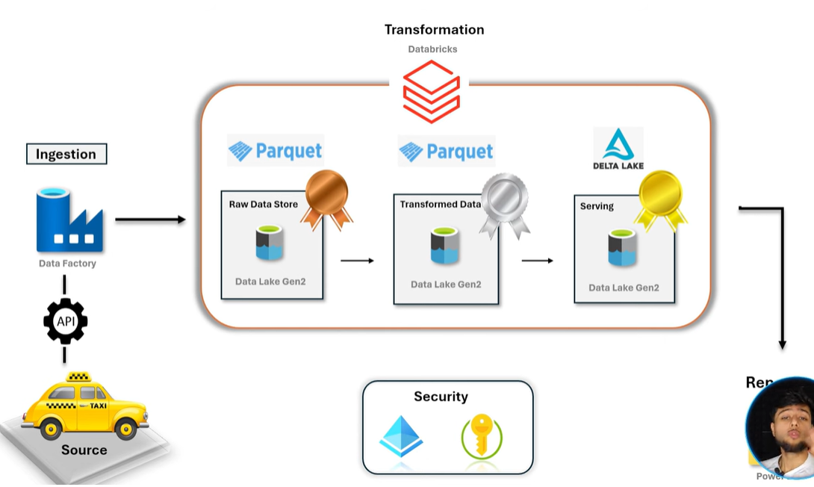
Phase 1

LS1/Conn1
LS2/Conn2

Data Lake
ADF
NYC Taxi

Linked Service Connection
Data Set Data that resides inside the Linked Service/Connection
- Create two linked services. One is for Source and other is for Target.
In the Properties of source Data Set we need to provide the Relative URL of the NYC Taxi data.
trip-data/green_tripdata_2025-01.parquet
Base URL was provided at the time of creation of the source Linked Service.
https://d37ci6vzurychx.cloudfront.net
- After creating the Linked Services, create Pipeline with COPY activity.
Now we have to repeat the steps for all the files of NYC Taxi of 2025.
To achieve this, we need to use ‘ForEach’ activity and a parameter.

In the source URI we will provide the parameter.
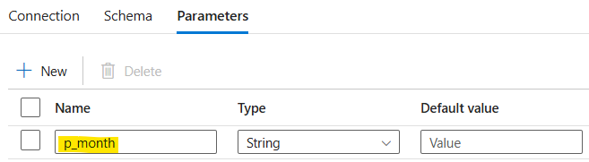
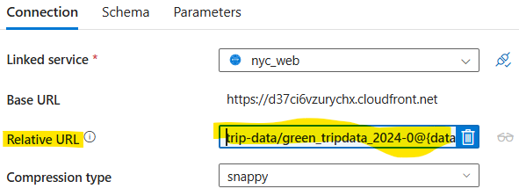
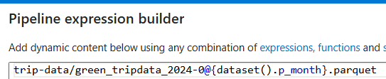
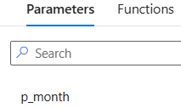
- Now, we have to add the ‘forEach’ which will increase the value of the p_month parameter.
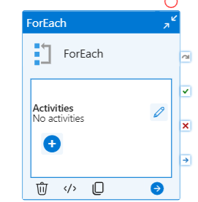
In forEach() we need to provide the range() inside Items.
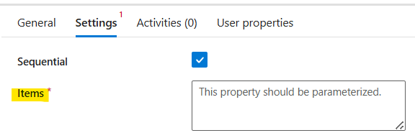
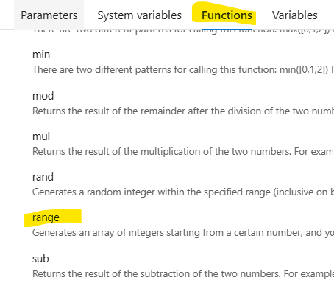
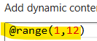
Cut the copy activity and paste inside ‘forEach’ by going to Activities tab and then use the forEach() variable in the parameter value.
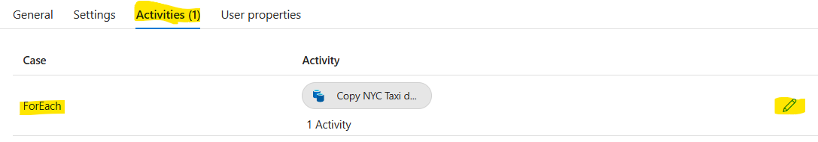
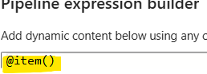
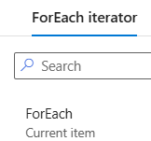
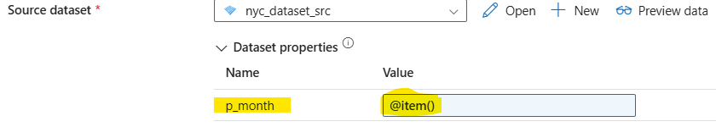

But this will work till count 9. After that we need to change the concatenation of the relative URI.
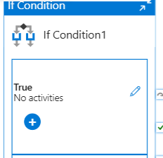
Condition-
@greater(@item,9)
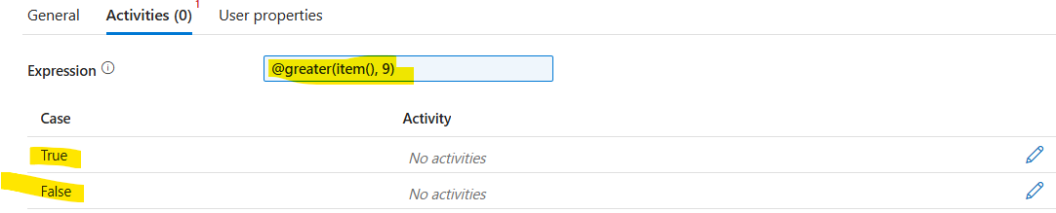
Run our normal activity when @Item <=9.
Copy the same activity and remove 0 when @item > 9
Here we need to create one new data set as we have to remove 0. So we will create a new parameter and pass the value @Item.
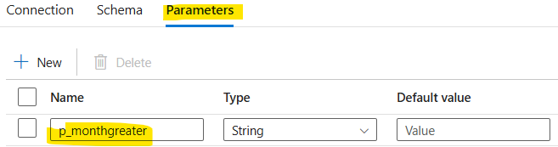
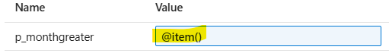

Bronze to Silver –
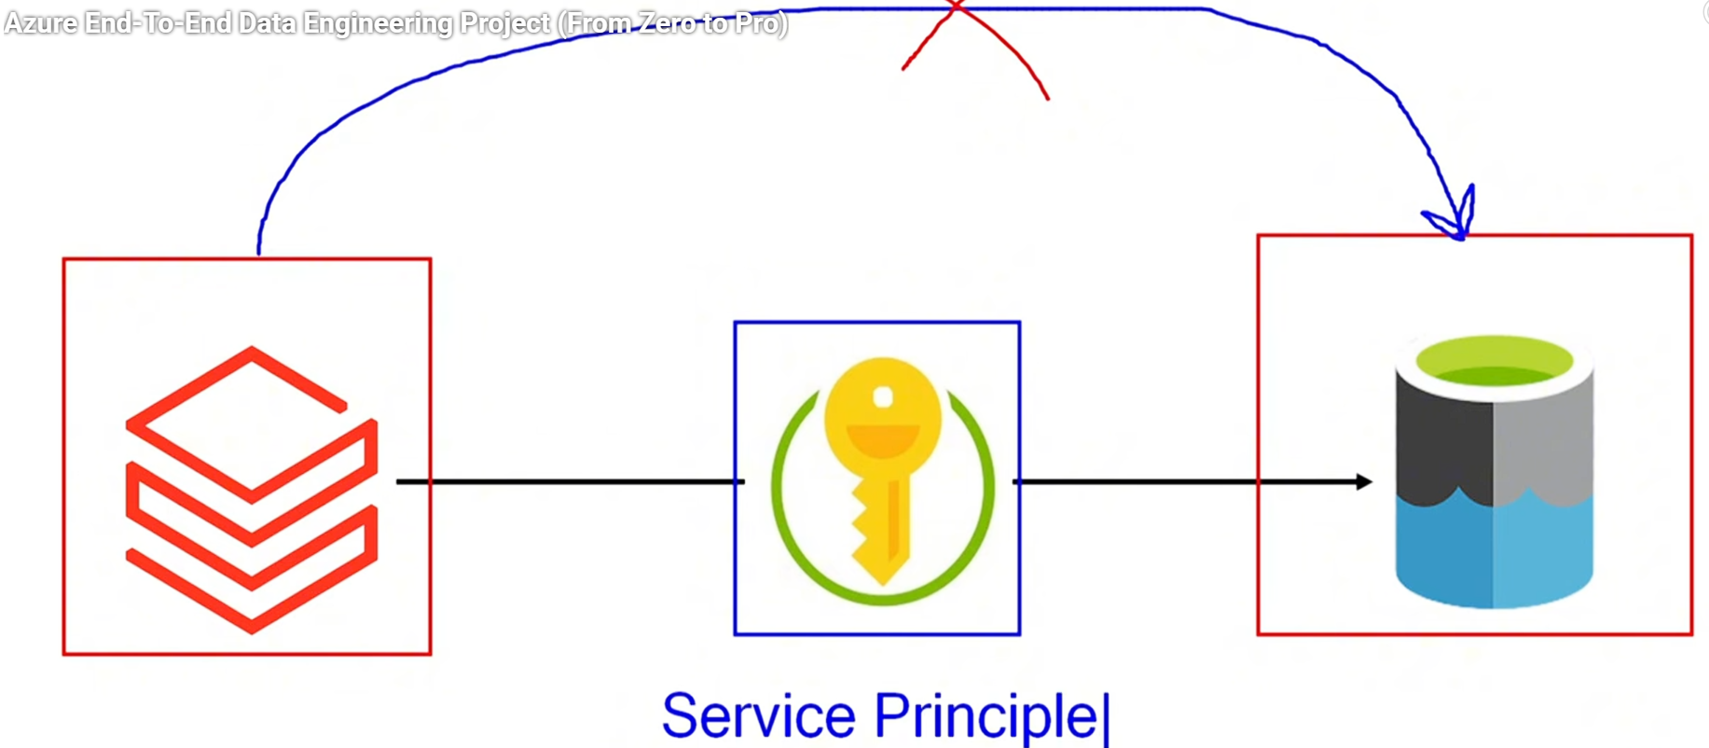
Read/Write
access

Application

Azure Data Lake will not allow Databricks to access data directly. To access data in Datalake, Databricks need ‘write’ permission. For that we need Service Priniciple.
It will create an application which has the ‘write’ permission to Datalake and then this service principle will be used by Databricks.
Steps –
- Create the application(Service Principle)
- Give Read/Write access to the application(Service Principle).
- Databricks can access Datalake by pulling this Service Principle.
Note – Databricks contains another Resource Group which is dedicated for managing the all clusters in the background.
Databricks –
Create Compute –
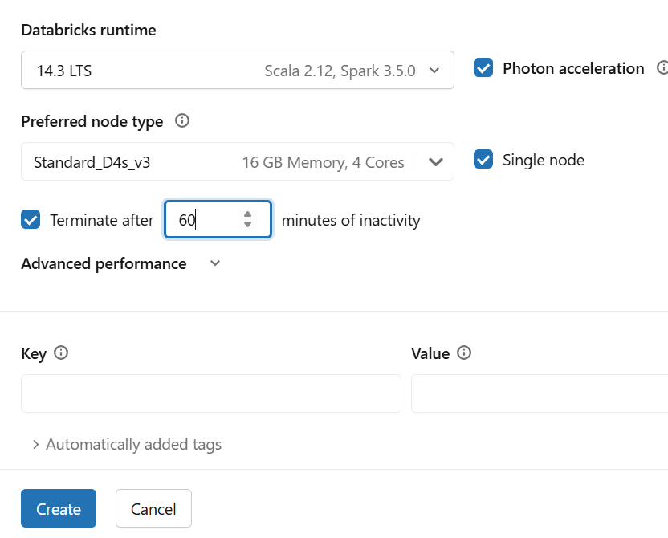
Data Access -
Below key is from Dalalake Storage keys-
kecccccys = 'uLTO5foTmQB6SjN776XvoV5tebC72zSRWxeRNo8+NliC3hP0eP11ij2tYVfo0hK7UxjFB2oOCIDc+AStDK2cHA=='

spark.conf.set(
"fs.azure.account.key.nyctaxisa389.dfs.core.windows.net",
"uLTO5foTmQB6SjN776XvoV5tebC72zSRWxeRNo8+NliC3hP0eP11ij2tYVfo0hK7UxjFB2oOCIDc+AStDK2cHA=="
)

--listdown the files in ADLS2-
dbutils.fs.ls('abfss://broze@nyctaxisa389.dfs.core.windows.net')
Reading the data –
Importing libraries-
from pyspark.sql.functions import *
from pyspark.sql.types import *
df_trip_type = spark.read.format('csv')\
.option('inferSchema', True)\
.option('header', True)\
.load('abfss://broze@nyctaxisa389.dfs.core.windows.net/trip_type')
df_trip_type.display()
df_trip_zone = spark.read.format('csv')\
.option('inferSchema', True)\
.option('header', True)\
.load('abfss://broze@nyctaxisa389.dfs.core.windows.net/trip_zone')
df_trip_zone.display()
Note - We can use structType() and DDL instead of inferSchema() if we want to create schema on our own.
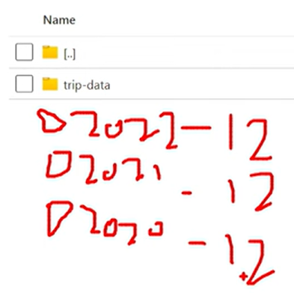
recursiveFileLookup() –
Reads all the files recursively within a folder.
df_trip = spark.read.format('parquet')\
.option('inferSchema', True)\
.option('header', True)\
.option('recursiveFileLookup', True)\
.load('abfss://broze@nyctaxisa389.dfs.core.windows.net/trip2024data')
Defining schema -
myschema = '''
VendorID BIGINT,
lpep_pickup_datetime TIMESTAMP,
lpep_dropoff_datetime TIMESTAMP,
store_and_fwd_flag STRING,
RatecodeID BIGINT,
PULocationID BIGINT,
DOLocationID BIGINT,
passenger_count BIGINT,
trip_distance DOUBLE,
fare_amount DOUBLE,
extra DOUBLE,
mta_tax DOUBLE,
tip_amount DOUBLE,
tolls_amount DOUBLE,
ehail_fee DOUBLE,
improvement_surcharge DOUBLE,
total_amount DOUBLE,
payment_type BIGINT,
trip_type BIGINT,
congestion_surcharge DOUBLE
'''

Data Transformation –
----------------------------------------------------------
We will write the data in Silver container.
Renaming column of df_trip_type
df_trip_type = df_trip_type.withColumnRenamed('description', 'trip_description')
Mode()-
There are 4 types of modes.
1)Append
2)Overwrite
3)Error – If a file is already present in a folder, it will throw Error saying already file exists.
4)Ignore – It will not write the data and will not throw any Error.
##writing file inse Silver container –
df_trip_type.write.format('parquet')\
.mode('append')\
.option("path", "abfss://silver@nyctaxisa389.dfs.core.windows.net/trip_type")\
.save()
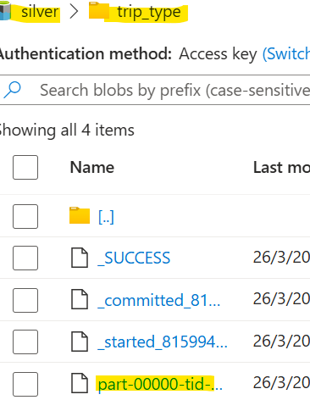
Split() –
We will chose a delimiter, it will convert it into a list
Ex- column ‘zone’ = Kolkata/Mumbai
Split() [Kolata, Mumbai]
Here, delimiter is ‘/’
Indexing ------ [0] [1]
df_trip_zone = df_trip_zone.withColumn('zone1', split(col('zone'),'/')[0])\
.withColumn('zone2', split(col('zone'),'/')[1])
df_trip_zone.display()

##writing file in Silver container –
df_trip_zone.write.format('parquet')\
.mode('append')\
.option("path", "abfss://silver@nyctaxisa389.dfs.core.windows.net/trip_zone")\
.save()
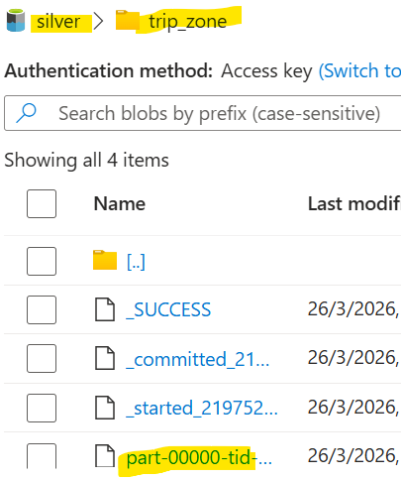
We will have 3 col in Trip Data –
1.Date 2.Year 3.Month
df_trip = df_trip.withColumn('trip_date', to_date('lpep_pickup_datetime'))\
.withColumn('trip_year', year('lpep_pickup_datetime'))\
.withColumn('trip_month', month('lpep_pickup_datetime'))
df_trip.display()
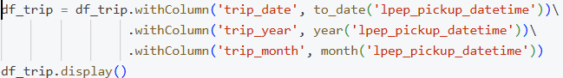
Select only few columns from the Data-Frame.
df_trip = df_trip.select('VendorID', 'PULocationID', 'fare_amount', 'total_amount')
##writing file in Silver container –
df_trip.write.format('parquet')\
.mode('append')\
.option('path', 'silver@nyctaxisa389.dfs.core.windows.net/trip2024data')\
.save()

We can use visualization –
display(df_trip)
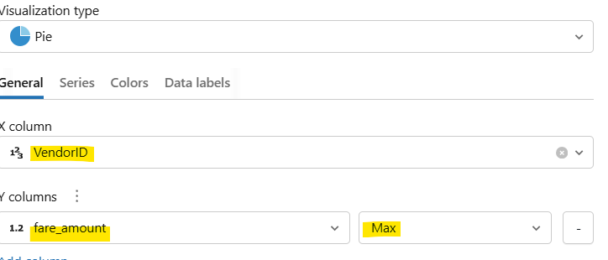
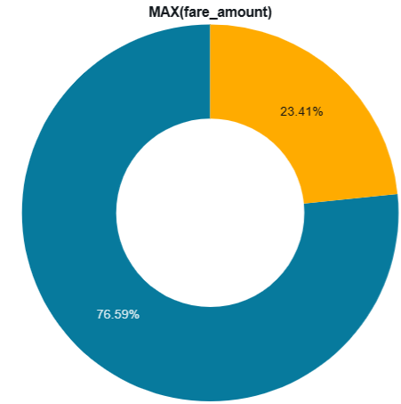
External vs Managed Table –
External tables are managed by ourselves. So if the Gold layer is managed by ourselves then we should create External table.
If Table gets dropped, Data will be still present. We will not lose the data.
Managed tables are managed by Databricks.
If the table gets dropped the data will also gets deleted.

Data Reading and Writing and Creating Delta Tables -
In Gold layer data will be stored in Delta format. After that it create table on top of it which is called Delta Table.
df_zone.write.format('delta')\
.mode('append')\
‘f’ concatenate variable and string
.option('external_location', f'{gold}/trip_zone')\
.saveAsTable('gold.trip_zone')

Parquet file + Detla_log/Transactional_log = Delta Table
Transactional log contains one .crc file and another .json file.
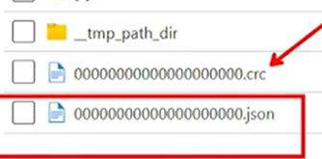
All the CRUD operations are stored in Delta_log.
After running the SQL query, it reads the whole log and all the versions then it gives the latest data.
Final step is to connect Delta tables with PowerBI.
DESCRIBE HISTORY <table_name>
Will give the detailed history of the table. It will show all the activity history performed on the table in log file.
Time Travel –
RESTORE <table_name> TO VERSION AS OF 0
It will show the data when table was created. This is because tables are version controlled in the ‘log file’. So here we don’t need to ‘ROLLBACK’ and ‘COMMIT’ explicitly.
Connection of Databricks Delta tables with PowerBI –
We can connect to PowerBI using Partner Connect in Databricks.

We need to download the connection file for PowerBI.
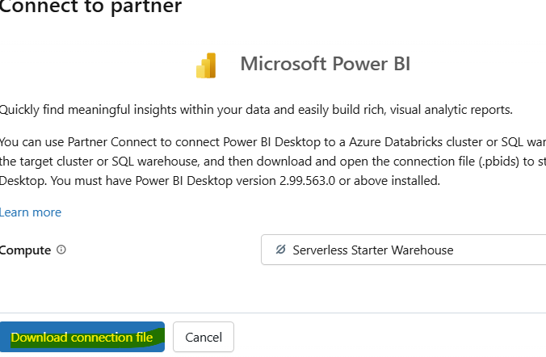

Then double click on the downloaded file. Then chose ‘Access Token’
Then download the Access Token from Databricks as shown below screen shot.
